**Software Requirement Specification**

**For**

**ATM BOOTH MANAGEMENT**

This work is based upon the submission of the summer 2018

“SWE131: Documentation of Software Engineering”, Department of Software Engineering (22th Batch)

**Submitted To**

**Mr. Khaled Been Badruzzaman Biplob**

**Lecturer,Department of software Engineering of DIU**

**# Debashish Roy**

**ID :171-35-2050**

**# Kanak kumar Sarkar**

**ID :171-35-2043**

Decription Page No

1. Chapter 1 03
   1. Introduction 03
   2. Scope 03
   3. Overview 03
2. Chapter 2 04
   1. User profile: 1 04
   2. User profile: 2 04
3. Chapter 3 05

3.1 List of Functional requirement

(1).3.1.1 Functional requirement: Manager……………………………. 05

(2).3.1.2 Functional requirement: Customer…………………………… 05

1. Chapter 4 06

4.1 Use case diagram

(1). 4.1.1 Use case diagram: Manager…………………………………… 06

(2). 4.1.1 Use case diagram: Customer…………………………………… 07

**Chapter 1**

* 1. **Introduction:**

The software **ATM**  is to be developed for Automated Teller Machines (ATM). An automated teller machine (ATM) is computerized telecommunications device that provides a financial institution's customers a secure method of performing financial transactions, in a public space without the need for a human bank teller. Through **ATM**, customers interact with a user-friendly interface that enables them to access their bank accounts and perform various transactions.

* 1. **Scope:**

This document applies to Automated Teller Machine software **ATM .** This software facilitates the user to perform various transactions in his account without going to bank. This software offers benefits such cash withdrawals, balance transfers, deposits, inquiries, credit card advances and other banking related operations for customers*.* It also allows the administrator to fix the tariffs and rules as and when required…

The software takes as input the login Id and the bank account number of the user for login purposes. The outputs then comprise of an interactive display that lets the user select the desirable function that he wants to perform.

* 1. **Overview:**

1. Chapter 2 describes both primary and secondary user profile
2. Chapter 3 shows the list of functional and non-functional requirement including mind-map and requirement prioritization.
3. In chapter 4, use case diagram was provided

**Chapter 2**

**2.1 User Profile:**

|  |  |
| --- | --- |
| **User Class** | **Notes on Characteristics** |
| **Type of User** | Primary |
| **Age range** | Up to 18 |
| **Frequency of use** | High |
| **Mandatory/Discretionary** | Discretionary |
| **Computer Experience** | No |
| **Education** | Yes |
| **Goals** | Poor educated |
| **Language Skills** | Bangla and English |
| **Number of Users** |  |
| **Training** | No |
| **Other system Used** | Yes |
| **Ways of Working** |  |

**Chapter 3**

**3.1 List of Functional Requirement:**

**3.1.1 Functional requirement:**

**Manager**

|  |  |
| --- | --- |
| **Requirement ID** | **FR.M.1** |
| **Requirement Name** | **Select who are you?** |
| **Description** | **Customer or Manager** |

|  |  |
| --- | --- |
| **Requirement ID** | **FR.M.2** |
| **Requirement Name** | **Sign in** |
| **Description** | **Manager can log in using user name and password** |

|  |  |
| --- | --- |
| **Requirement ID** | **FR.M.3** |
| **Requirement Name** | **Manage booth item** |
| **Description** | **Manger can change password if user forget password or lost their card.Manage every booth system and input money if booth’s is null…..** |

**3.1.2 Functional requirement:**

**Customer**

|  |  |
| --- | --- |
| **Requirement ID** | **FR.C.1** |
| **Requirement Name** | **Log in or Input Card** |
| **Description** | **Client or user input card to cheak or transfer money…** |

|  |  |
| --- | --- |
| **Requirement ID** | **FR.C.2** |
| **Requirement Name** | **Verification** |
| **Description** | **Client input password or input fingerprint in device...** |

|  |  |
| --- | --- |
| **Requirement ID** | **FR.C.3** |
| **Requirement Name** | **Withdraw money and Transfer Money** |
| **Description** | **Client can withdraw money and transfer money with account number ….** |

|  |  |
| --- | --- |
| **Requirement ID** | **FR.C.4** |
| **Requirement Name** | **Exchange money** |
| **Description** | **Client Exchange money from booth…(Dollar to Tk)** |

|  |  |
| --- | --- |
| **Requirement ID** | **FR.C.5** |
| **Requirement Name** | **Bil payment** |
| **Description** | **Client can give their electric bill,Gas bill from booth….** |

|  |  |
| --- | --- |
| **Requirement ID** | **FR.C.6** |
| **Requirement Name** | **Give Feedback** |
| **Description** | **Client can give feedback to improve the service….** |

**3.1.3 Non -functional requirement:**

**Customer:**

|  |  |
| --- | --- |
| **Requirement ID** | **FR.C.1** |
| **Requirement Name** | **ATM Card reader, Keypad, Empty slot, Empty Envelope,Printer, Display** |
| **Description** | **For client can access atm booth with atm card,and see the GUI for display, Clear button if client insert wrong input.** |

|  |  |
| --- | --- |
| **Requirement ID** | **FR.C.2** |
| **Requirement Name** | **Security.** |
| **Description** | **Client can attempt 3 time for password.** |

|  |  |
| --- | --- |
| **Requirement ID** | **FR.C.3** |
| **Requirement Name** | **Password time** |
| **Description** | **Client must insert password within 20sec.** |

|  |  |
| --- | --- |
| **Requirement ID** | **FR.C.4** |
| **Requirement Name** | **Empty pages** |
| **Description** | **For client can have a money clearance.** |

|  |  |
| --- | --- |
| **Requirement ID** | **FR.C.5** |
| **Requirement Name** | **Cash Dispenser** |
| **Description** | **Cash dispenser will open for client.** |

|  |  |
| --- | --- |
| **Requirement ID** | **FR.C.6** |
| **Requirement Name** | **Security Camera** |
| **Description** | **Security Camera for extra security.** |

**Chapter 4**

* 1. **Problems:**

**(1).4.1.1 Use case diagram: Manager**

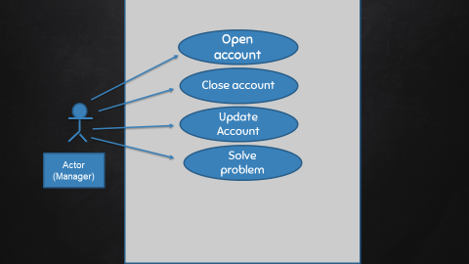

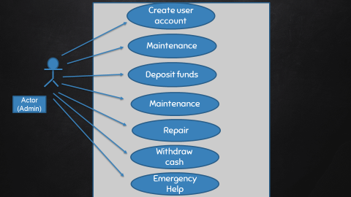

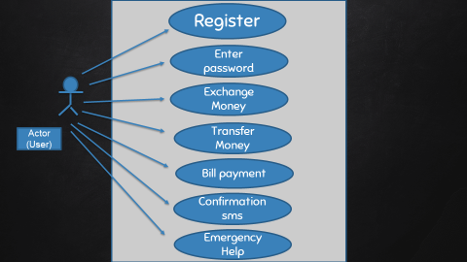**(2). 4.1.1 Use case diagram: Customer**

**1. Card Damage.**

**2. Forget password.**

**3. If Card blocked in ATM booth.**

**4. Insufficient Balance.**

**5. If network will slow or terminate.**

**6. Transaction sms will not reach at phone.**

**7. If clearance paper will null.**

**8. If client send money on wrong account number.**